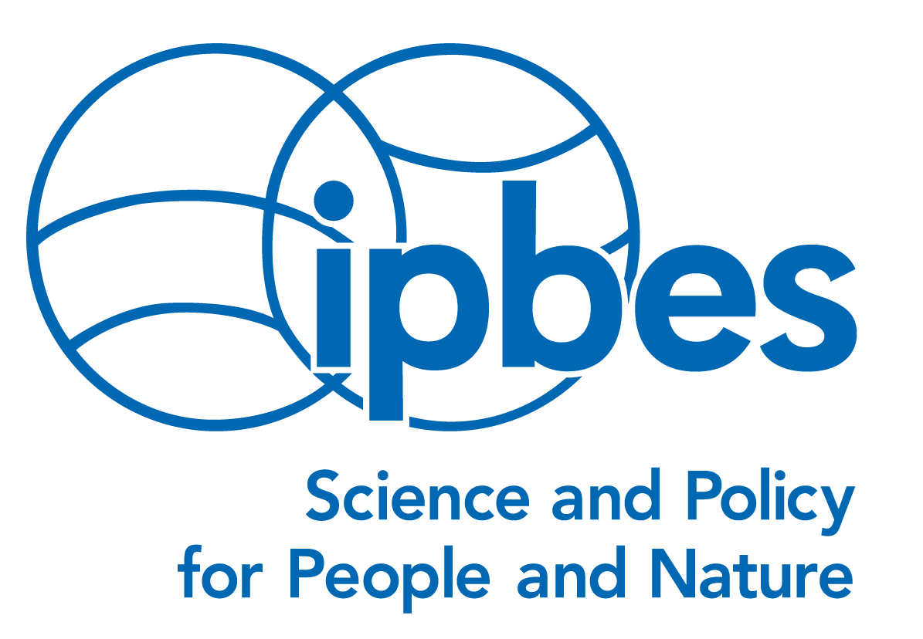 |  | 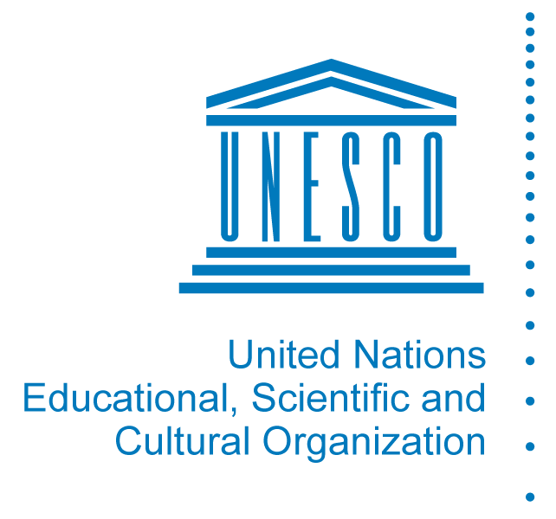 | 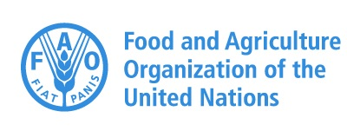 | 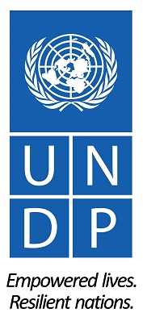
Media Release

For Immediate Release: Issued by the Secretariat of the
Intergovernmental Science-Policy Platform on Biodiversity and Ecosystem Services (IPBES)
on Tuesday, 28 March 2017

Ref: P/17/01

Agriculture Is Part of the Pollinator Solution:
Intensive Farming Can Harm or Help Pollination

Bonn (IPBES News) – Although large-scale agriculture can be a significant threat to animal pollinators, intensive farming can also prevent pollinator decline and support sustainable food production, if implemented in an ecologically sustainable manner. This was the message from six pollination experts in an article published on Tuesday in the Ecology Letters journal.

The article, “Ecological intensification to mitigate impacts of conventional intensive land use on pollinators and pollination”, builds on the outcomes of the landmark 2016 Assessment Report on Pollinators, Pollination and Food Production, by the Intergovernmental Science-Policy Platform on Biodiversity and Ecosystem Services (IPBES).

Lead author of the article, Dr. Anikó Kovács-Hostyánszki said: “Large-scale farming can reduce the quality of landscapes for biodiversity and disrupt plant-pollinator communities through the conversion of natural habitats for agriculture. Our work shows that agriculture can also play a key role in supporting pollinators. This can be achieved by practices such as intercropping, crop rotation, farm-level diversification and the reduced use of agrochemicals.”

The IPBES Assessment had highlighted policy options for safeguarding pollinators – one of which was ecological intensification to transform agriculture. The new article takes this further by synthesizing the risks to pollinators and pollination specifically due to land use and land management – critically evaluating the potential of ecological intensification to address, and even reverse current trends that are damaging pollinator communities and causing wide-spread pollination shortages.

Welcoming the publication of the article, Dr. Anne Larigauderie, the Executive Secretary of IPBES, said: “In 2016, IPBES and the Convention on Biological Diversity recognized the dual role of agriculture as both a threat to pollinators and a potential solution to many of the challenges which they face. This new work, building on the IPBES Assessment, will help decision-makers to reduce the negative impacts of intensive farming on pollination and offer new insights into policy options in support of pollinators.”

The article makes the point that for ecological intensification to support pollinator communities, there should be tailored management solutions, institutional and productivity innovations, and a central role for ecologists, commercial agronomists and extension workers in co-developing and exchanging knowledge with farmers, Government agencies and environmental NGOs.

Note to Editors:

The authors of the new article are: Anikó Kovács-Hostyánszki (Hungary); Anahí Espíndola (USA); Adam Vanbergen (UK); Josef Settele (Germany); Claire Kremen (USA); and Lynn Dicks (UK).

An abstract and the full text of the article may be accessed at: https://goo.gl/N3wSfO

The IPBES Assessment on Pollinators, Pollination and Food Production and a list of its major policy impacts may be accessed at: https://goo.gl/rNndxY

IPBES is an independent intergovernmental body comprising 126 member States. Established by Governments in 2012, it provides policymakers with objective scientific assessments about the state of knowledge regarding the planet’s biodiversity, ecosystems and the benefits they provide to people, as well as the tools and methods to protect and sustainably use these vital natural assets. To some extent IPBES does for biodiversity what the IPCC does for climate change. For more information about IPBES and its assessments visit www.ipbes.net

ENQUIRIES & INTERVIEWS:

Robert Spaull
media@ipbes.net
+49 174 356 6551
www.ipbes.net

Follow Us:

Twitter: @IPBES www.facebook.com/ipbes youtube.com/ipbeschannel

